Week-8 Practical Student Records Application using Spring Boot and MongoDB [Bhardwaj, 2520090182]
To develop a Student Records REST API using Spring Boot, MongoDB, JWT Authentication, CRUD Operations, and Input Validation.

Spring Boot Application Running Successfully
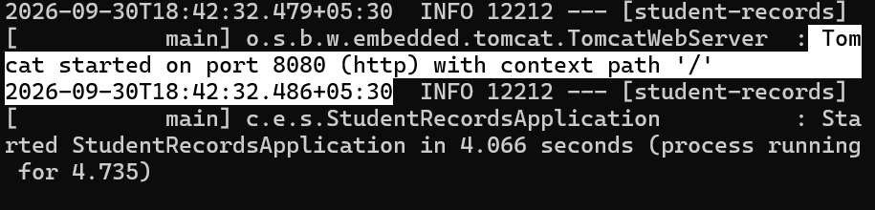

Registering the user:
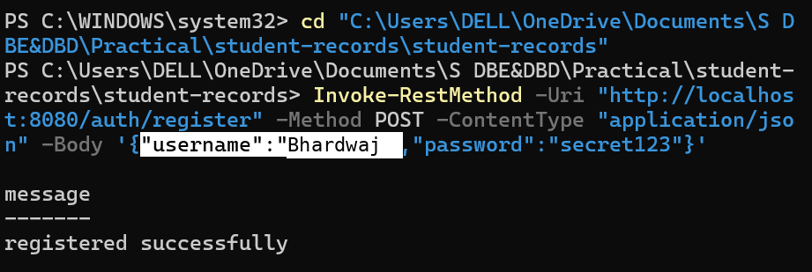

User Login and JWT Token Generation:
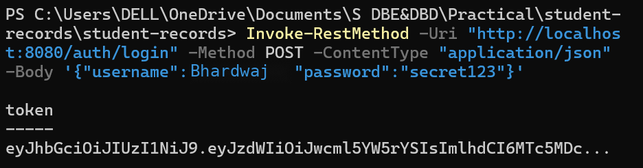

Saving the JWT Token:
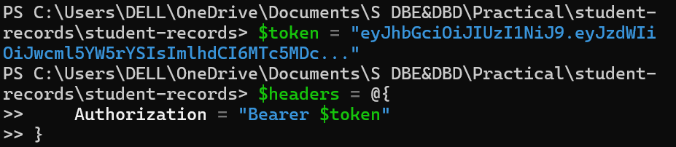

GET All Students Records:
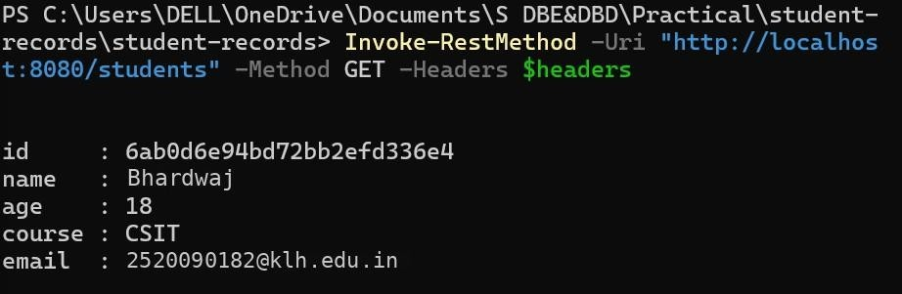

Student Record Updated Successfully:
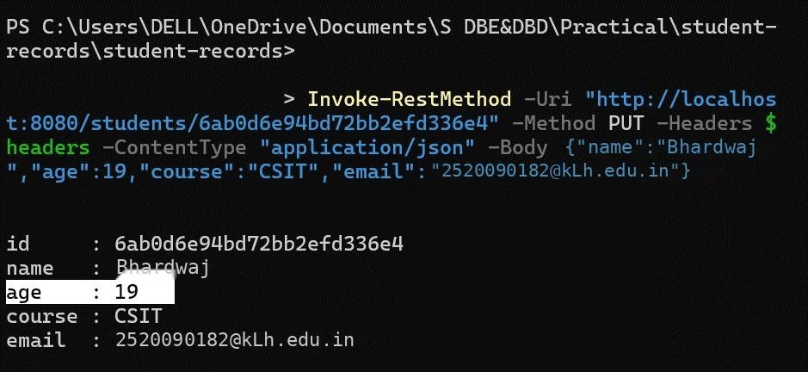

Test Validation: Student Input Validation and Error Handling

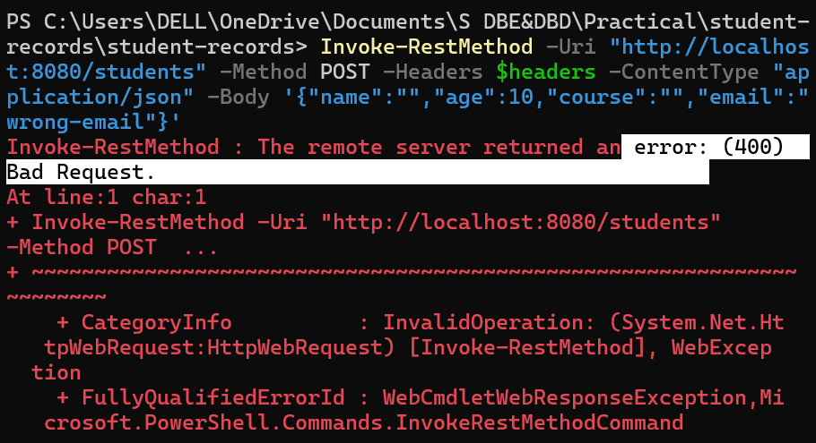

Student Records Stored in MongoDB
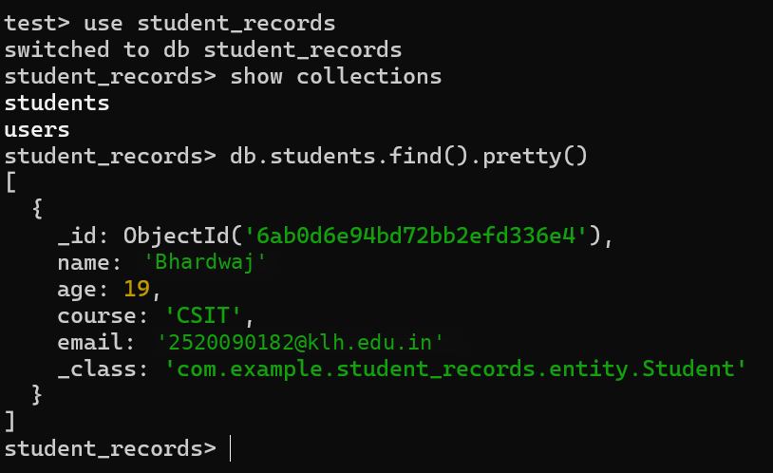

Delete the student record
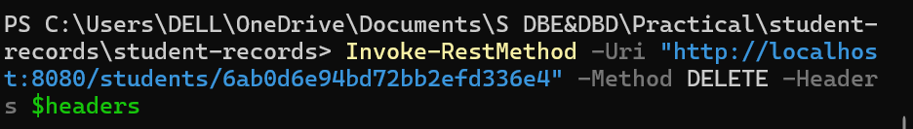
Output on PowerShell 1: [Student Record Deleted Successfully]

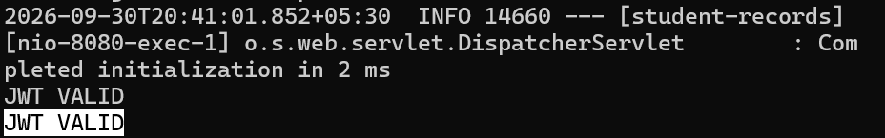

Student data deletion verification

MongoDB Records After Deletion
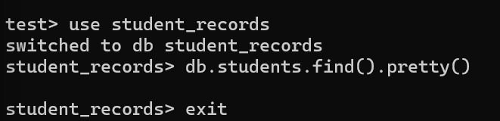

Folder Structure:
Week-8_Practical_Student_Records/
│
├── students-records
│ ├── pom.xml
│ ├── mvnw
│ ├── mvnw.cmd
│ ├── .mvn/
│ ├── src/
│ │ └── main/
│ │ ├── java/
│ │ │ └── com/
│ │ │ └── example/
│ │ │ └── student_records/
│ │ │ ├── StudentRecordsApplication.java
│ │ │ ├── controller/
│ │ │ ├── dto/
│ │ │ ├── entity/
│ │ │ ├── exception/

│ | │ | │ | ├── repository/
│ | │ | │ | ├── security/
│  │ | │  │ | │  │ | └── service/
│ │ └── resources/
│ │ └── application.properties
│ │
│ └── target/
Codes:

Main Application
  - StudentRecordsApplication.java

package com.example.student_records;

import org.springframework.boot.SpringApplication;
import org.springframework.boot.autoconfigure.SpringBootApplication;

@SpringBootApplication
public class StudentRecordsApplication {

public static void main(String[] args)
{ SpringApplication.run(StudentRecordsApplication.class, args);
}

}

Entity
  - Student.java
package com.example.student_records.entity; import org.springframework.data.annotation.Id;
import org.springframework.data.mongodb.core.mapping.Document;

@Document(collection="students") public class Student {

@Id

private String id;

private String name; private Integer age; private String course; private String email;

public String getId() { return id;
}

public void setId(String id) { this.id = id;
}

public String getName() { return name;
}

public void setName(String name) { this.name = name;
}

public Integer getAge() { return age;
}

public void setAge(Integer age) { this.age = age;
}

public String getCourse() { return course;
}

public void setCourse(String course) { this.course = course;
}

public String getEmail() { return email;
}

public void setEmail(String email) { this.email = email;
}
}

  - User.java
package com.example.student_records.entity; import org.springframework.data.annotation.Id;
import org.springframework.data.mongodb.core.index.Indexed; import org.springframework.data.mongodb.core.mapping.Document;

@Document(collection = "users") public class User {

@Id
private String id;

@Indexed(unique = true) private String username;

private String password;

public String getId() { return id;
}

public void setId(String id) { this.id = id;
}

public String getUsername() { return username;
}

public void setUsername(String username) { this.username = username;
}

public String getPassword() { return password;
}

public void setPassword(String password) { this.password = password;
}
}

DTO

  - StudentRequest.java

package com.example.student_records.dto;

import jakarta.validation.constraints.Email; import jakarta.validation.constraints.Min; import jakarta.validation.constraints.NotBlank; import jakarta.validation.constraints.NotNull;

public class StudentRequest {

@NotBlank(message = "name is required") private String name;

@NotNull(message = "age is required")
@Min(value = 16, message = "age must be at least 16") private Integer age;

@NotBlank(message = "course is required") private String course;

@NotBlank(message = "email is required") @Email(message = "a valid email is required") private String email;

public String getName() { return name;
}

public void setName(String name) { this.name = name;
}

public Integer getAge() { return age;
}

public void setAge(Integer age) { this.age = age;
}

public String getCourse() { return course;
}

public void setCourse(String course) { this.course = course;
}

public String getEmail() {

return email;
}

public void setEmail(String email) { this.email = email;
}
}

- RegisterRequest.java

package com.example.student_records.dto;

import jakarta.validation.constraints.NotBlank; import jakarta.validation.constraints.Size;

public class RegisterRequest { @NotBlank private String username;

@NotBlank
@Size(min = 6, message = "password must be at least 6 characters") private String password;

public String getUsername() { return username;
}

public void setUsername(String username) { this.username = username;
}

public String getPassword() { return password;
}

public void setPassword(String password) { this.password = password;
}
}

- LoginRequest.java

package com.example.student_records.dto;

import jakarta.validation.constraints.NotBlank; public class LoginRequest {
@NotBlank
private String username;

@NotBlank
private String password;

public String getUsername() { return username;
}

public void setUsername(String username) { this.username = username;
}

public String getPassword() { return password;
}

public void setPassword(String password) { this.password = password;
}
}

Repository
  - StudentRepository.java
package com.example.student_records.repository; import com.example.student_records.entity.Student;
import org.springframework.data.mongodb.repository.MongoRepository;

public interface StudentRepository extends MongoRepository<Student, String>
{
}

  - UserRepository.java
package com.example.student_records.repository; import com.example.student_records.entity.User;
import org.springframework.data.mongodb.repository.MongoRepository;

import java.util.Optional;

public interface UserRepository extends MongoRepository<User, String> {

Optional<User> findByUsername(String username);
}

Service
  - StudentService.java

package com.example.student_records.service;

import com.example.student_records.dto.StudentRequest; import com.example.student_records.entity.Student;
import com.example.student_records.repository.StudentRepository; import org.springframework.stereotype.Service;

import java.util.List; import java.util.Optional;

@Service
public class StudentService {

private final StudentRepository repository;

public StudentService(StudentRepository repository) { this.repository = repository;
}

public Student create(StudentRequest r) { Student s = new Student();
apply(s, r);

return repository.save(s);
}

public List<Student> getAll() { return repository.findAll();
}

public Optional<Student> getById(String id) { return repository.findById(id);
}

public Optional<Student> update(String id, StudentRequest r) {

return repository.findById(id).map(s -> { apply(s, r);
return repository.save(s);
});
}
public boolean delete(String id) { if (! repository.existsById(id)) {
return false;
}

repository.deleteById(id);

return true;
}

private void apply(Student s, StudentRequest r) {

s.setName(r.getName());
s.setAge(r.getAge()); s.setCourse(r.getCourse()); s.setEmail(r.getEmail());
}
}

Controller
  - StudentController.java

package com.example.student_records.controller;

import com.example.student_records.dto.StudentRequest; import com.example.student_records.entity.Student;
import com.example.student_records.service.StudentService; import jakarta.validation.Valid;
import org.springframework.http.ResponseEntity; import org.springframework.web.bind.annotation.*;

import java.util.List;

@RestController @RequestMapping("/students")

public class StudentController {

private final StudentService service;

public StudentController(StudentService service) { this.service = service;
}

@PostMapping
public ResponseEntity<Student> create(
@Valid @RequestBody StudentRequest r) {

return ResponseEntity
.status(201)
.body(service.create(r));
}

@GetMapping
public List<Student> getAll() { return service.getAll();
}

@GetMapping("/{id}")
public ResponseEntity<Student>
getById( @PathVariable String id) {

return service.getById(id)
.map(ResponseEntity::ok)
.orElse(ResponseEntity.notFound().build());
}

@PutMapping("/{id}")
public ResponseEntity<Student>
update( @PathVariable String id,
@Valid @RequestBody StudentRequest r) {

return service.update(id, r)
.map(ResponseEntity::ok)
.orElse(ResponseEntity.notFound().build());
}

@DeleteMapping("/{id}") public ResponseEntity<Void>
delete( @PathVariable String id) {

return service.delete(id)

? ResponseEntity.noContent().build()
: ResponseEntity.notFound().build();

}
}

- AuthController.java
package com.example.student_records.controller; import com.example.student_records.dto.LoginRequest;
import com.example.student_records.dto.RegisterRequest; import com.example.student_records.entity.User;
import com.example.student_records.repository.UserRepository; import com.example.student_records.security.JwtUtil;

import jakarta.validation.Valid;

import org.springframework.http.ResponseEntity;

import org.springframework.security.authentication.AuthenticationManager; import org.springframework.security.authentication.UsernamePasswordAuthenticationT oken;

import org.springframework.security.crypto.password.PasswordEncoder; import org.springframework.web.bind.annotation.*;
import java.util.Map;

@RestController @RequestMapping("/auth") public class AuthController {

private final UserRepository users; private final PasswordEncoder encoder;
private final AuthenticationManager manager; private final JwtUtil jwt;

public AuthController(
UserRepository users, PasswordEncoder encoder, AuthenticationManager manager, JwtUtil jwt) {

this.users = users; this.encoder = encoder; this.manager = manager; this.jwt = jwt;

}

@PostMapping("/register")
public ResponseEntity<?> register(
@Valid @RequestBody RegisterRequest r) {
if (users.findByUsername(r.getUsername()).isPresent()) { return ResponseEntity
.badRequest()
.body(Map.of(
"error",
"username already taken"
));
}
User user = new User(); user.setUsername(r.getUsername()); user.setPassword(
encoder.encode(r.getPassword())
);
users.save(user); return ResponseEntity
.status(201)
.body(Map.of(
"message",
"registered successfully"
));
}

@PostMapping("/login")
public ResponseEntity<?> login(
@Valid @RequestBody LoginRequest r) {

manager.authenticate( new
UsernamePasswordAuthenticationT oken( r.getUsername(), r.getPassword()
)
);

return ResponseEntity.ok( Map.of(

"token",

jwt.generateToken(r.getUsername())
)
);
}
}

Security
  - SecurityConfig.java
package com.example.student_records.security; import org.springframework.context.annotation.Bean;
import org.springframework.context.annotation.Configuration;

import org.springframework.security.authentication.AuthenticationManager; import org.springframework.security.config.annotation.authentication.configuration
.AuthenticationConfiguration;

import org.springframework.security.config.annotation.web.builders.HttpSecurity; import org.springframework.security.config.http.SessionCreationPolicy;

import org.springframework.security.crypto.bcrypt.BCryptPasswordEncoder; import org.springframework.security.crypto.password.PasswordEncoder;

import org.springframework.security.web.SecurityFilterChain; import org.springframework.security.web.authentication.UsernamePasswordAuthenticat ionFilter;

@Configuration
public class SecurityConfig {

private final JwtAuthFilter jwtAuthFilter;

public SecurityConfig(JwtAuthFilter jwtAuthFilter) { this.jwtAuthFilter = jwtAuthFilter;
}

@Bean
public PasswordEncoder passwordEncoder() { return new BCryptPasswordEncoder();
}

@Bean

public AuthenticationManager authenticationManager( AuthenticationConfiguration configuration) throws Exception {

return configuration.getAuthenticationManager();
}

@Bean
public SecurityFilterChain filterChain( HttpSecurity http)
throws Exception {

return http
.csrf(csrf -> csrf.disable())

.sessionManagement(session -> session.sessionCreationPolicy(
SessionCreationPolicy.STATELESS
)
)

.authorizeHttpRequests(auth -> auth
.requestMatchers("/auth/**")
.permitAll()

.anyRequest()
.authenticated()
)

.addFilterBefore(
jwtAuthFilter, UsernamePasswordAuthenticationFilter.class
)

.build();
}
}

  - JwtUtil.java
package com.example.student_records.security; import io.jsonwebtoken.*;
import io.jsonwebtoken.security.Keys;

import org.springframework.beans.factory.annotation.Value;

import org.springframework.stereotype.Component;

import javax.crypto.SecretKey;
import java.nio.charset.StandardCharsets; import java.util.Date;

@Component
public class JwtUtil {

@Value("${jwt.secret}") private String secret;

@Value("${jwt.expiration-ms}") private long expirationMs;

private SecretKey key() { return

Keys.hmacShaKeyFor(
secret.getBytes(StandardCharsets.UTF_8)
);
}

public String generateToken(String username) { Date now = new Date();
return Jwts.builder()
.setSubject(username)
.setIssuedAt(now)
.setExpiration(
new Date(now.getTime() + expirationMs)
)
.signWith(key(), SignatureAlgorithm.HS256)
.compact();
}

public String extractUsername(String token) {

return Jwts.parserBuilder()
.setSigningKey(key())
.build()
.parseClaimsJws(token)
.getBody()
.getSubject();
}

public boolean isValid(String token) {

try {

Jwts.parserBuilder()
.setSigningKey(key())
.build()
.parseClaimsJws(token); return

true;

} catch (JwtException | IllegalArgumentException e) {

return false;
}
}
}

- JwtAuthFilter.java
package com.example.student_records.security; import jakarta.servlet.*;
import jakarta.servlet.http.*;

import org.springframework.security.authentication.UsernamePasswordAuthenticationT oken; import org.springframework.security.core.context.SecurityContextHolder; import org.springframework.security.core.userdetails.UserDetailsService; import
org.springframework.security.web.authentication.WebAuthenticationDetailsSou rce; import org.springframework.stereotype.Component;
import org.springframework.web.filter.OncePerRequestFilter;
import java.io.IOException; @Component
public class JwtAuthFilter extends OncePerRequestFilter {

private final JwtUtil jwtUtil;
private final UserDetailsService userDetailsService;

public JwtAuthFilter(
JwtUtil jwtUtil,
UserDetailsService userDetailsService) { this.jwtUtil = jwtUtil;

this.userDetailsService = userDetailsService;
}

@Override
protected void doFilterInternal( HttpServletRequest request, HttpServletResponse response, FilterChain chain)
throws ServletException, IOException {

String header = request.getHeader("Authorization"); if (header != null && header.startsWith("Bearer ")) {
String token = header.substring(7); if (jwtUtil.isValid(token)) {
System.out.println("JWT VALID");

String username =
jwtUtil.extractUsername(token);

var details =
userDetailsService.loadUserByUsername(username);

var authentication =
new UsernamePasswordAuthenticationToken( details,
null, details.getAuthorities()
);

authentication.setDetails(
new WebAuthenticationDetailsSource()
.buildDetails(request)
);

SecurityContextHolder
.getContext()
.setAuthentication(authentication);

} else {

System.out.println("JWT INVALID");
}
}

chain.doFilter(request, response);
}
}

- CustomUserDetailsService.java

package com.example.student_records.security;

import com.example.student_records.repository.UserRepository;

import org.springframework.security.core.userdetails.*; import org.springframework.stereotype.Service;

@Service
public class CustomUserDetailsService implements UserDetailsService { private final UserRepository userRepository;
public CustomUserDetailsService(UserRepository userRepository) { this.userRepository = userRepository;
}

@Override
public UserDetails loadUserByUsername(String username) throws UsernameNotFoundException {

var user = userRepository
.findByUsername(username)
.orElseThrow(() ->
new UsernameNotFoundException("User not found"));

return User.withUsername(user.getUsername())
.password(user.getPassword())
.authorities("USER")
.build();
}
}

Exception Handling
  - GlobalExceptionHandler.java

package com.example.student_records.exception;

import org.springframework.http.ResponseEntity;
import org.springframework.web.bind.MethodArgumentNotValidException;

import org.springframework.web.bind.annotation.ExceptionHandler; import org.springframework.web.bind.annotation.RestControllerAdvice;

import java.util.HashMap; import java.util.Map;

@RestControllerAdvice
public class GlobalExceptionHandler {

@ExceptionHandler(MethodArgumentNotValidException.class) public ResponseEntity<Map<String, Object>> handleValidation(
MethodArgumentNotValidException ex) { Map<String, String> errors = new HashMap<>();
ex.getBindingResult()
.getFieldErrors()
.forEach(error ->
errors.put(
error.getField(), error.getDefaultMessage()
)
);

Map<String, Object> body = new HashMap<>();

body.put("error", "VALIDATION_ERROR"); body.put("details", errors);

return ResponseEntity.badRequest().body(body);
}
}

Configuration

application.properties

spring.application.name=student-records spring.data.mongodb.uri=mongodb://localhost:27017/student_records jwt.secret=replace-this-with-a-long-random-secret-at-least-32-characters jwt.expiration-ms=3600000

server.port=8080

Maven Configuration
  - pom.xml

<?xml version="1.0" encoding="UTF-8"?>
<project xmlns="http://maven.apache.org/POM/4.0.0" xmlns:xsi="http://www.w3.org/2001/XMLSchema-instance"
xsi:schemaLocation="http://maven.apache.org/POM/4.0.0 https://maven.apache.org/xsd/maven-4.0.0.xsd">

<modelVersion>4.0.0</modelVersion>

<parent>
<groupId>org.springframework.boot</groupId>
<artifactId>spring-boot-starter-parent</artifactId>
<version>3.5.6</version>
<relativePath/>
</parent>

<groupId>com.example</groupId>
<artifactId>student-records</artifactId>
<version>0.0.1-SNAPSHOT</version>
<name>student-records</name>
<description>Student Records Application</description>

<properties>
<java.version>17</java.version>
</properties>

<dependencies>

<dependency>
<groupId>org.springframework.boot</groupId>
<artifactId>spring-boot-starter-web</artifactId>
</dependency>

<dependency>
<groupId>org.springframework.boot</groupId>
<artifactId>spring-boot-starter-data-mongodb</artifactId>
</dependency>

<dependency>
<groupId>org.springframework.boot</groupId>
<artifactId>spring-boot-starter-validation</artifactId>
</dependency>

<dependency>

<groupId>org.springframework.boot</groupId>
<artifactId>spring-boot-starter-security</artifactId>
</dependency>

<dependency>
<groupId>io.jsonwebtoken</groupId>
<artifactId>jjwt-api</artifactId>
<version>0.11.5</version>
</dependency>

<dependency>
<groupId>io.jsonwebtoken</groupId>
<artifactId>jjwt-impl</artifactId>
<version>0.11.5</version>
<scope>runtime</scope>
</dependency>

<dependency>
<groupId>io.jsonwebtoken</groupId>
<artifactId>jjwt-jackson</artifactId>
<version>0.11.5</version>
<scope>runtime</scope>
</dependency>

<dependency>
<groupId>org.springframework.boot</groupId>
<artifactId>spring-boot-starter-test</artifactId>
<scope>test</scope>
</dependency>

</dependencies>

<build>
<plugins>
<plugin>
<groupId>org.springframework.boot</groupId>
<artifactId>spring-boot-maven-plugin</artifactId>
</plugin>
</plugins>
</build>

</project>

